Week 03

* Regular expression is an advanced code, which returns query or text in a specific format.
  + SELECT *

FROM suppliers

WHERE REGEXP_LIKE(description, ‘[0-9]{3}[-.][0-9]{3}[-.][0-9]{4}’);

* Regular expression cheat sheet
  + <http://www.cbs.dtu.dk/courses/27610/regular-expressions-cheat-sheet-v2.pdf>
* JustLee books database
  + <https://www.chegg.com/homework-help/questions-and-answers/database-sql-justlee-books-database-drop-table-customers-cascade-constraints-drop-table-or-q21244383>

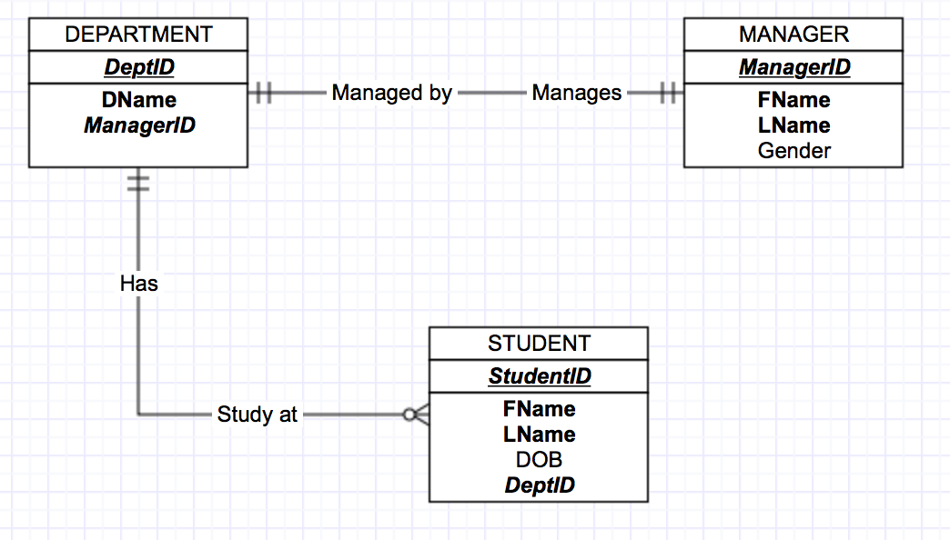

create table DEPARTMENT (

DeptID int primary key,

DName varchar(15) not null,

ManagerID int not null unique);

alter table DEPARTMENT

add constraint MANG_DEPT_FK foreign key (ManagerID) REFERENCES Manager(ManagerID);

insert into DEPARTMENT (DeptID, DName, ManagerID)

values (11, 'Engineering', 10011);

insert into DEPARTMENT (DeptID, DName, ManagerID)

values (22, 'Marketing', 20022);

insert into DEPARTMENT (DeptID, DName, ManagerID)

values (33, 'Art', 30033);

insert into DEPARTMENT (DeptID, DName, ManagerID)

values (44, 'Sales', 40044);

insert into DEPARTMENT (DeptID, DName, ManagerID)

values (55, ' Life Sci ', 50055);

create table STUDENT (

StudID int primary key,

FName varchar(12) not null,

LName varchar(12) not null,

DeptID int not null,

DOB Date,

GPA char(1) not null check (GPA='A' OR GPA='B' OR GPA='C' OR GPA='D'),

foreign key (DeptID) references Department(DeptID));

insert into STUDENT

values (1111, 'Asem', 'Omari', 11, '1989-MAR-27', 'A');

insert into STUDENT

values (2222, 'Tariq', 'Karimi', 22, '1999-AUG-02', 'D');

insert into STUDENT

values (3333, 'Seoyoung', 'Min', 33, '2001-JAN-01', 'B');

create table MANAGER (

ManagerID int primary key,

FName varchar(12) not null,

LName varchar(12) not null,

Gender varchar(6) check (Gender= 'Male' OR Gender='Female'));

insert into MANAGER (ManagerID, FName, LName, Gender)

values (10011, 'Alex', 'Conrad', 'Male');

insert into MANAGER (ManagerID, FName, LName, Gender)

values (20022, 'Sadiq', 'Alcic', 'Male');

insert into MANAGER (ManagerID, FName, LName, Gender)

values (30033, 'Stefanie', 'Jorg', 'Female');

/* Testing Check for Gender */

insert into MANAGER (ManagerID, FName, LName, Gender)

values (40044, 'Fatimah', 'Ahmad', 'Fem');

insert into MANAGER (ManagerID, FName, LName, Gender)

values (40044, 'Fatimah', 'Ahmad', 'Female');

insert into MANAGER (ManagerID, FName, LName, Gender)

values (50055, 'Arnaldo', 'Melo', 'Male');

select * from STUDENT;

select * from DEPARTMENT;

select * from MANAGER;

select lower(FName) as "LOWER_NAME" from MANAGER;

select upper(FName) as "UPPER_NAME" from MANAGER;

select INITCAP(FName) as "CAPITALIZED_INITIAL" from MANAGER;

select substr(FName, 2, 3) as "NAME_SUBSTRING" from MANAGER;

select substr(FName, -4, 2) as "NAME_SUBSTRING" from MANAGER;

select substr(FName, -6, 2) as "NAME_SUBSTRING" from MANAGER;

select instr(FName, 'a') as "NAME_INSTRING" from MANAGER;

select instr(FName, 'ad') as "NAME_INSTRING" from MANAGER;

select length(FName) as "NAME_LENGTH" from MANAGER;

select lpad(FName, 12, '$#') from MANAGER;

select rpad(FName, 12, '*') from MANAGER;

select rtrim(DName, 'ing') from DEPARTMENT;

select trim(DName) from DEPARTMENT;

select replace(DName, 'ing', 'ING') from DEPARTMENT;

select FName, LName, concat(concat(FName, ' '), LName) as "FULL_NAME" from STUDENT;

select abs(SYSDATE-DOB) as "AGE_IN_DAYS" from STUDENT;

select trunc(months_between(current_date, DOB)) as "AGE_IN_MONTHS" from STUDENT;

select DOB, add_months(DOB, 3) as "UPDATED_MEMBERSHIP" from STUDENT;

select DOB, DOB+3 as "UPDATED_MEMBERSHIP" from STUDENT;

select dob, to_char(DOB, 'YYYY-MM-DD-DY') as "FORMATTED_DATE_OF_BIRTH" from STUDENT;